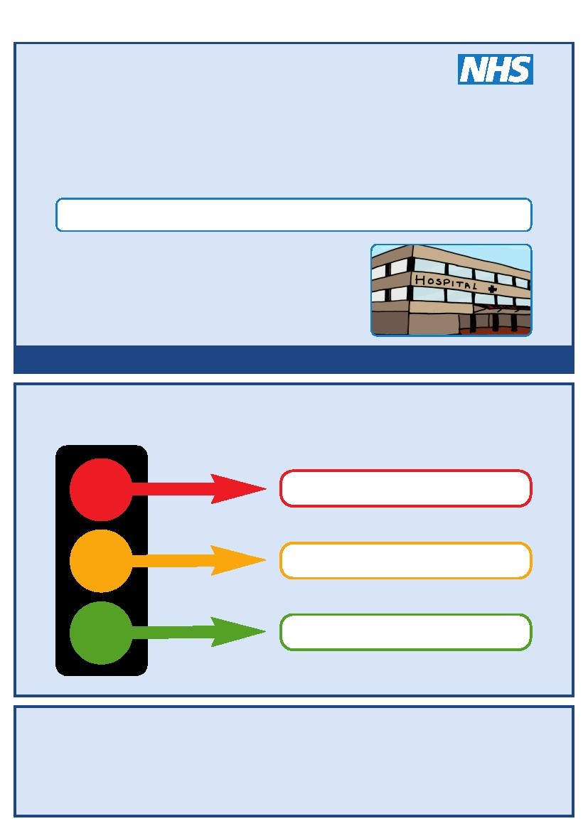
This is my
Hospital Passport
For people with learning disabilities coming into hospital
My name is:
If I have to go to hospital this book needs to
go with me, it gives hospital staff important
information about me.
It needs to hang on the end of my bed and a
copy should be put in my notes.
This passport belongs to me. Please return it when I am discharged.
Nursing and medical staff please look at my passport
before you do any interventions with me.
Things you must know about me
Things that are important to me
My likes and dislikes
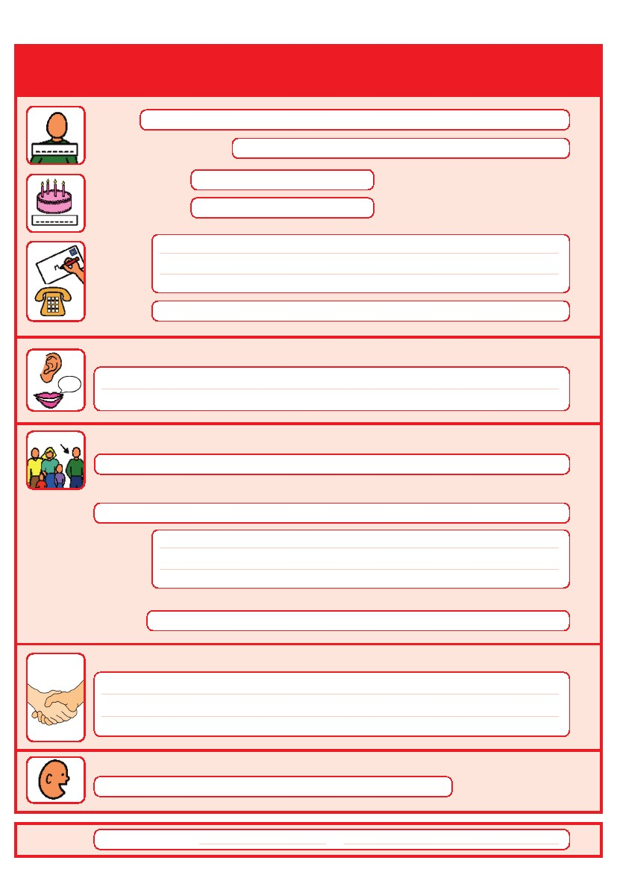
Things you must know about me
Name:
Likes to be known as:
NHS number:
Date of Birth:
Address:
Tel No:
How I communicate/What language I speak:
Family contact person, carer or other support:
Relationship e.g. Mum, Dad, Home Manager, Support Worker:
Address:
Tel No:
My support needs and who gives me the most support:
My carer speaks:
Date completed
by
1
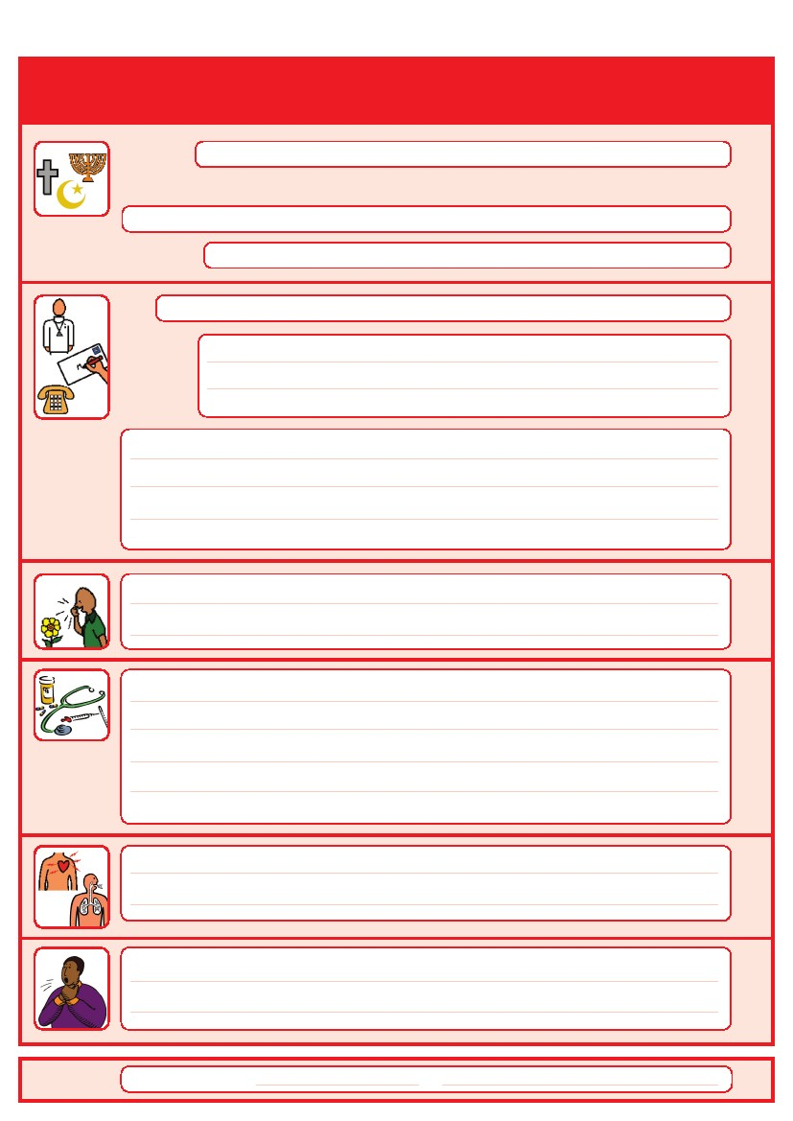
Things you must know about me
Religion:
Religious/Spiritual needs:
Ethnicity:
Address:
GP:
Tel No:
Other services/professionals involved with me:
Allergies:
Medical Interventions – how to take my blood, give injections, BP etc.
Heart
Breathing problems:
Date completed
Risk of choking, Dysphagia (eating, drinking and swallowing):
by
2
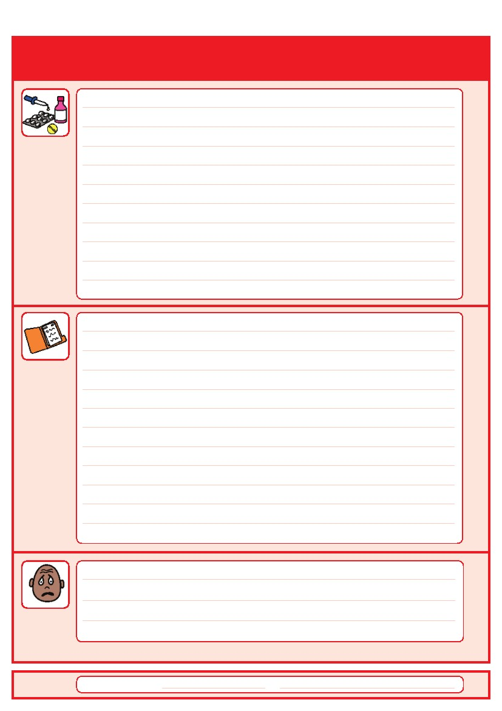
Things you must know about me
Current medication:

My medical history and treatment plan:
Date completed
What to do if I am anxious:
by
3
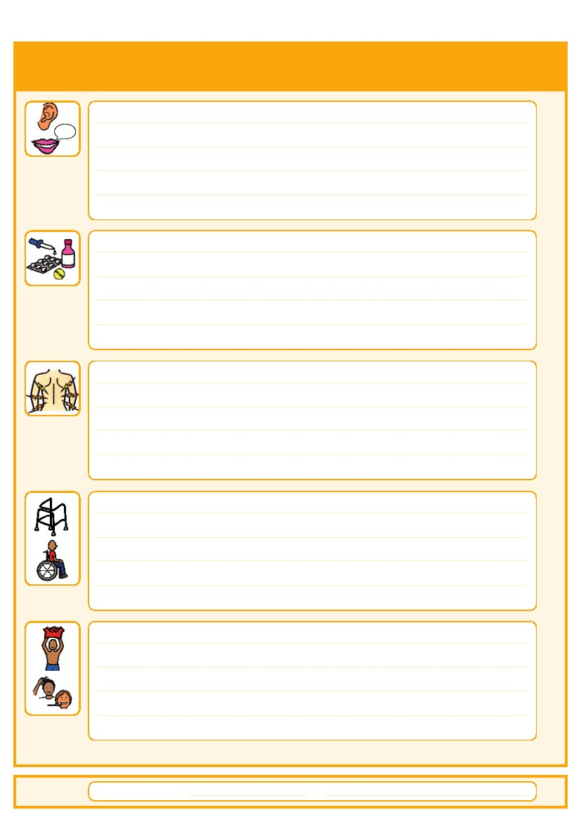
Things that are important to me
Date completed
How to communicate with me:
How I take medication: (whole tablets, crushed tablets, injections, syrup)
How you know I am in pain:
Moving around: (Posture in bed, walking aids)
Personal care: (Dressing, washing, etc)
by
4
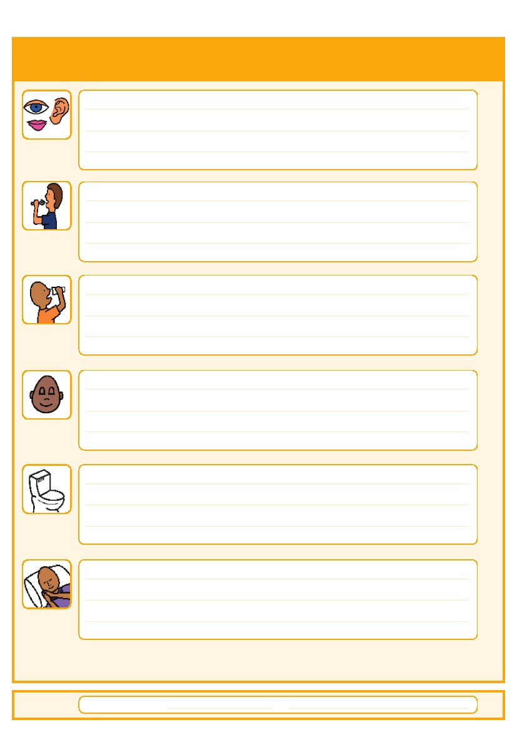
Things that are important to me
Date completed
Seeing/Hearing: (Problems with sight or hearing)
How I eat: (Food cut up, pureed, risk of choking, help with eating)
How I drink: (Drink small amounts, thickened fluids)
How I keep safe: (Bed rails, support with challenging behaviour)
How I use the toilet: (Continence aids, help to get to toilet)
Sleeping: (Sleep pattern/routine)
by
5
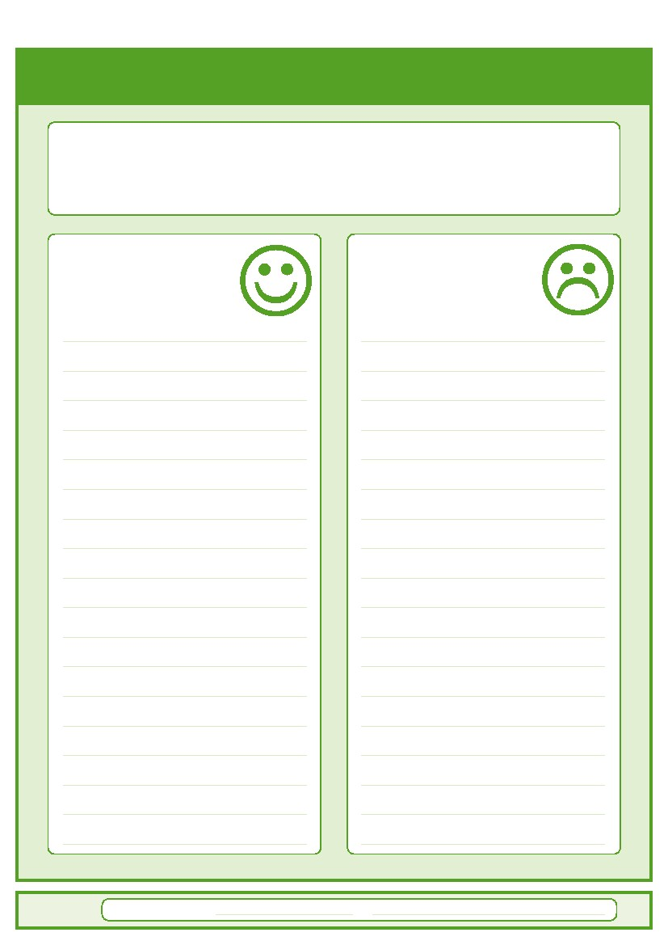
My likes and dislikes
Likes: for example - what makes me happy, things I like to do
i.e. watching TV, reading, music, routines.
Dislikes: for example - don’t shout, food I don’t like, physical touch.
Date completed
Things I like
Please do this:
Things I don’t like
Don’t do this:
by
6
7
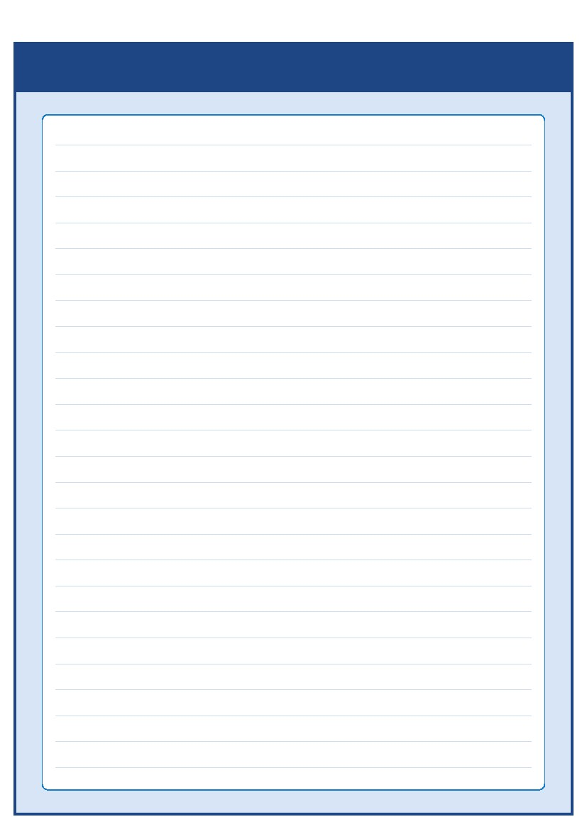 Notes

Hospital Switchboard: 01253 300000

Community Learning Disability Teams

Blackpool Team
Telephone Number: 01253 477803

Fylde and Wyre Team
Telephone Number: 01253 956179

Patient Relations Department
The Patient Relations Department offer impartial advice and deal with many concerns or complaints the Trust receives. You can contact them via:

Tel: 01253 955589
Email: bfwh.patientrelations@nhs.net
Patient Relations Department, Blackpool Victoria Hospital, Whinney Heys Road, Blackpool FY3 8NR

Options available
If you’d like a large print, audio, Braille or
a translated version of this leaflet then please call:
01253 955588

Contacts and useful websites
www.easyhealth.org.uk
www.intellectualdisability.info
www.mencap.org.uk/gettingitright
8
Please contact your local community learning disability team
if you have any questions about the passport
This Hospital Passport was developed by the South West London Access to Acute Group and based
on original work by Gloucester Partnership NHS Trust.
Thank you to The Baked Bean Theatre Company, members of our community, Wandsworth
Community Learning Disability Team, members of the St Georges Access to Acute working party,
Merton CTPLD Community Nurses and the Corporate Design department at Wandsworth Council who
all inputted into the redesign of this document.
AS.42a (12.09)

